Task 3: Networking Basics for Cyber Security
- Basic networking concepts (IP, MAC, DNS, TCP/UDP):

IP(Internet Protocol):
A unique numerical label for devices on a network, crucial for data routing but also a key identifier for attackers to track activity, launch attacks (like DDoS), or perform identity spoofing, making IP protection vital through firewalls, VPNs, and monitoring to secure digital communications and privacy.
In Simple Words, Like a digital home address, an IP address identifies a specific device (computer, phone, server) on a network, enabling data packets to find their destination.

MAC : Message Authentication Code
Message Authentication Code, a cryptographic checksum verifying data integrity and authenticity (origin) using a secret key, ensuring messages aren't altered and come from trusted senders. It can also mean Mandatory Access Control, a strict access control model where the system, not users, dictates permissions, common in high-security environments.

DNS (Domain Name System) :
It involves protecting the internet's "phone book" (translating names to IP addresses) from attacks like hijacking, poisoning, and DDoS, which can redirect users to fake sites, steal data, or spread malware, using tools like DNSSEC and DNS filtering for authentication and blocking malicious traffic. It's a critical defense layer, as attackers exploit DNS to disrupt operations and steal information
TCP( Transfer Control Protocol):
It is like sending a registered letter: it's reliable, confirms delivery, and ensures everything arrives in order (used for email, web browsing).

UDP (User Datagram Protocol) :
It is like sending a postcard: it's fast, sends data quickly without confirmation, and might lose a few (used for video streaming, online gaming), making it a trade-off between speed and guaranteed delivery in cybersecurity.

Installation Of Wireshark:
Steps for Installation:
1. www.mozillafirefox.com
2. www.wireshark.org
3. Download wireshark from the website
4. Install it ,after download.
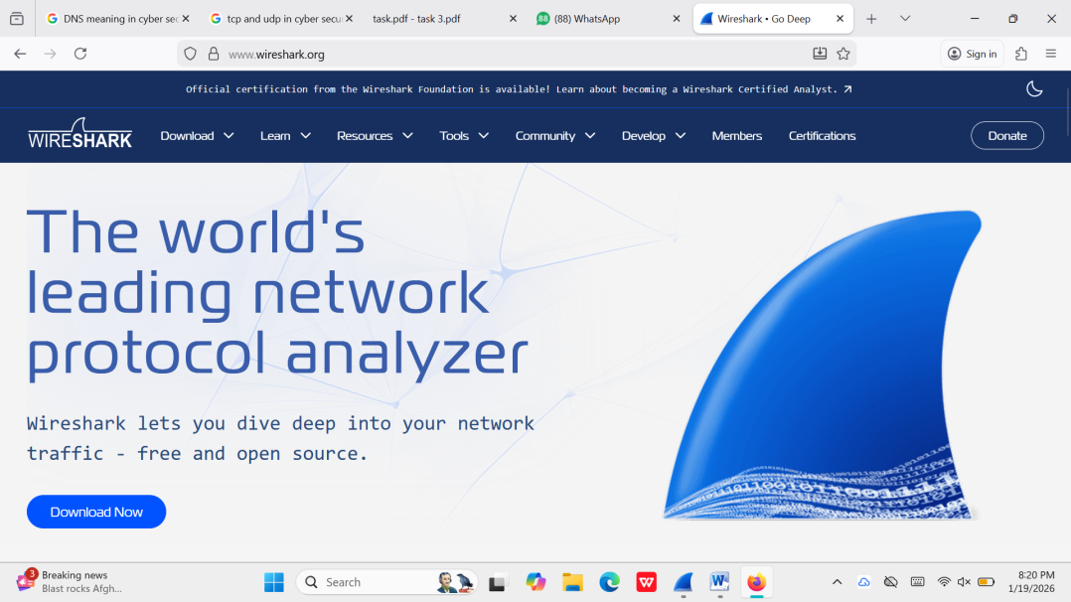

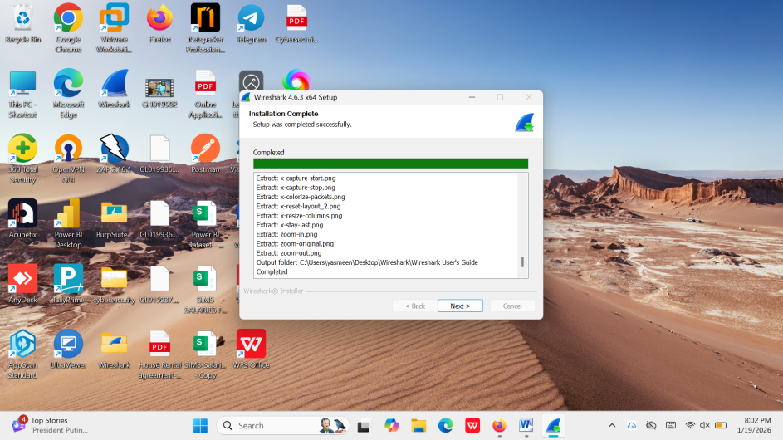

Filter packets by protocol (HTTP, DNS, TCP).
1.HTTP
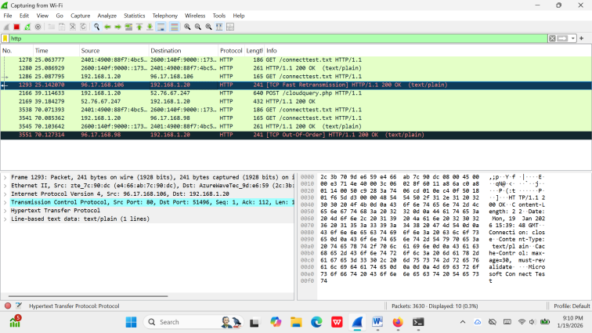
2.DNS :
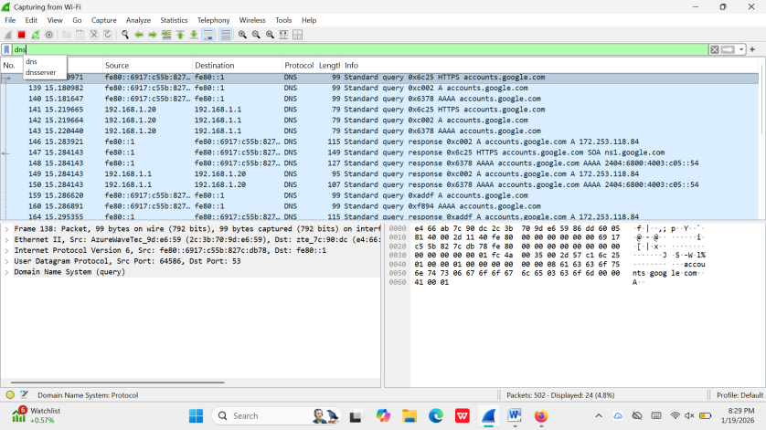

3.TCP :
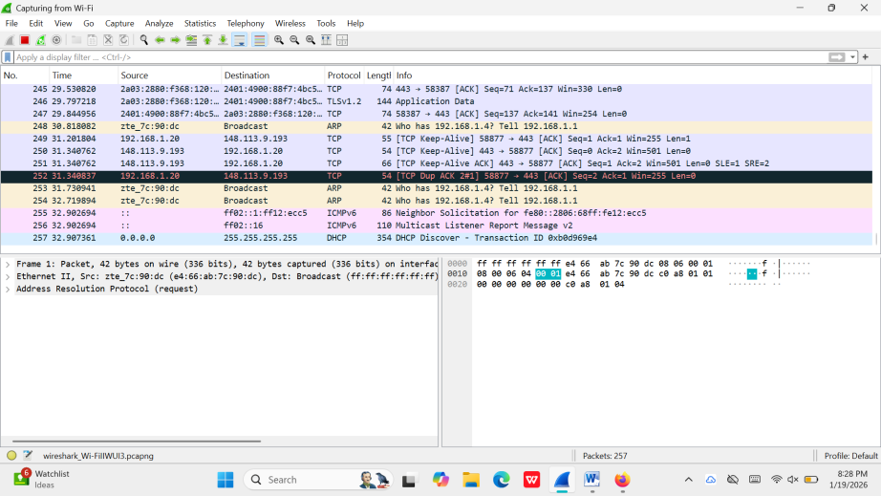

5. Identify Plain-Text Traffic vs Encrypted Traffic
Plain-text traffic means the data is sent in a readable form over the network.
Encrypted traffic means the data is protected and cannot be read easily.

Plain-Text Traffic (HTTP)
- Uses HTTP protocol.
- Data can be read directly in Wireshark.
- Usernames, passwords, and web pages may be visible.
- Not secure.
- Example: Visiting a website that starts with http://

Encrypted Traffic (HTTPS)
- Uses HTTPS protocol.
- Data is encrypted, so content is not readable.
- Protects user data from attackers.
- More secure.
- Example: Visiting a website that starts with https://

Observation in Wireshark
- HTTP packets show readable content.
- HTTPS packets show encrypted data (random characters).
- This proves why HTTPS is safer than HTTP.

6. Capture DNS Queries and Analyze Them
DNS (Domain Name System) helps convert website names into IP addresses.

Steps to Capture DNS Traffic
- Start Wireshark capture.
- Apply filter:
dns
- Open a browser and visit any website.
- DNS packets appear in Wireshark.

What We Observe
- Website name requested (example: google.com)
- DNS server IP address
- Response showing the website’s IP address

Why DNS Analysis is Important
- Shows which websites are accessed.
- Helps detect malicious or suspicious domains.
- Useful in cyber security investigations.

Simple Example
- You type www.google.com
- DNS converts it to an IP address
- Your system connects using that IP

Steps Performed in the Task
- Installed Wireshark.
- Started capturing live network traffic.
- Applied filters like:
  - http
  - dns
  - tcp
- Observed TCP three-way handshake:
  - SYN
  - SYN-ACK
  - ACK
- Compared plain-text traffic (HTTP) with encrypted traffic (HTTPS).
- Captured and analyzed DNS queries.
- Saved packet capture files (.pcap).
- Wrote observations in simple language.

Key Observations
- HTTP traffic can be read in plain text.
- HTTPS traffic is encrypted and secure.
- DNS requests show which websites are accessed.
- TCP ensures reliable data transfer using handshake.

